### **Python Virtual Machine (PVM)**

The Python Virtual Machine (PVM) is the runtime engine of the Python programming language. It is responsible for executing Python bytecode generated by the Python interpreter. Here's a breakdown of its key components and how it works:

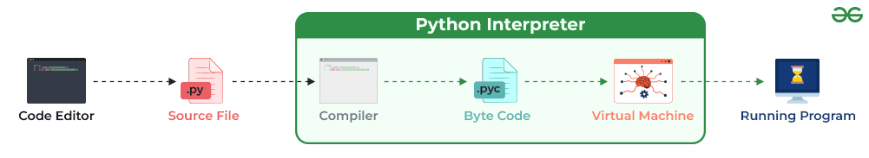

### **Components of Python Virtual Machine (PVM):**

* **Interpreter:** The Python interpreter reads Python source code, parses it into abstract syntax trees (ASTs), and compiles it into bytecode. The bytecode is a low-level representation of the source code that can be executed by the PVM.
* **Bytecode**: Bytecode is a platform-independent representation of the Python source code. It consists of a sequence of instructions that the PVM can execute. Bytecode files have a **.pyc** extension and are generated by the Python interpreter when a Python script is imported or executed.
* **Execution Engine:** The execution engine of the PVM interprets and executes the bytecode instructions. It traverses the bytecode instructions sequentially, performing the necessary operations as directed by the bytecode.

### **How Python Virtual Machine Works:**

* **Loading Bytecode:** When a Python script is executed, the Python interpreter loads the bytecode generated from the script into memory.
* **Interpreting Bytecode:** The execution engine of the PVM interprets each bytecode instruction one by one. It fetches the next instruction, decodes it, and executes the corresponding operation.
* **Executing Operations:** The PVM executes various operations specified by the bytecode instructions. These operations can include arithmetic calculations, variable assignments, function calls, and control flow statements (such as loops and conditionals).
* Managing Memory and Resources: The PVM manages memory allocation and deallocation for objects created during program execution. It also handles system resources, such as file handles and network connections.

#### 

#### **Standard Library**

* Python includes a comprehensive standard library containing pre-written modules and functions to handle a wide range of tasks. The Python Virtual Machine (PVM) seamlessly interfaces with these libraries, enabling users to execute complex operations effortlessly without the need to develop them from scratch.
* **Garbage Collection:** The PVM includes a garbage collector that automatically deallocates memory for objects that are no longer referenced by the program. This helps prevent memory leaks and ensures efficient memory usage.
* **Platform Independence:** The PVM provides platform independence, allowing Python code to run on different operating systems without modification. It abstracts away the underlying hardware and operating system details, providing a consistent execution environment for Python programs.

**Advantages of Python Virtual Machine**

The Python Virtual Machine (PVM) offers several advantages:

**1. Platform Independence:** Python code runs on the PVM, which abstracts away underlying hardware and operating system details. This ensures that Python programs can be executed across different platforms without modification.

**2. Portability:** Since Python programs run on the PVM, they can be easily ported to different environments without requiring recompilation or modification. This portability makes Python an ideal choice for developing cross-platform applications.

**3. Memory Management:** The PVM manages memory allocation and deallocation automatically, using techniques such as garbage collection. This simplifies memory management for developers and helps prevent memory-related errors such as memory leaks.

**4. Dynamic Typing:** Python is a dynamically typed language, meaning variable types are determined at runtime. The PVM handles dynamic typing seamlessly, allowing for flexible and expressive code.

**5. Interoperability:** Python can easily interface with code written in other languages such as C/C++, Java, and .NET. The PVM facilitates this interoperability, enabling Python programs to leverage existing libraries and frameworks.

**6. Performance Optimization:** The PVM includes features such as bytecode compilation and optimization, which can improve the performance of Python programs. Additionally, developers can use tools like PyPy and Cython to further optimize code execution.

**7. Scalability:** Python's support for multi-threading and multiprocessing, combined with the capabilities of the PVM, allows for scalable and concurrent execution of Python applications. This makes Python suitable for building both small scripts and large-scale distributed systems.

**8. Community Support:** The PVM is backed by a vibrant community of developers who contribute to its ongoing development and improvement. This ensures that Python remains up-to-date with the latest advancements in programming language design and technology.